* 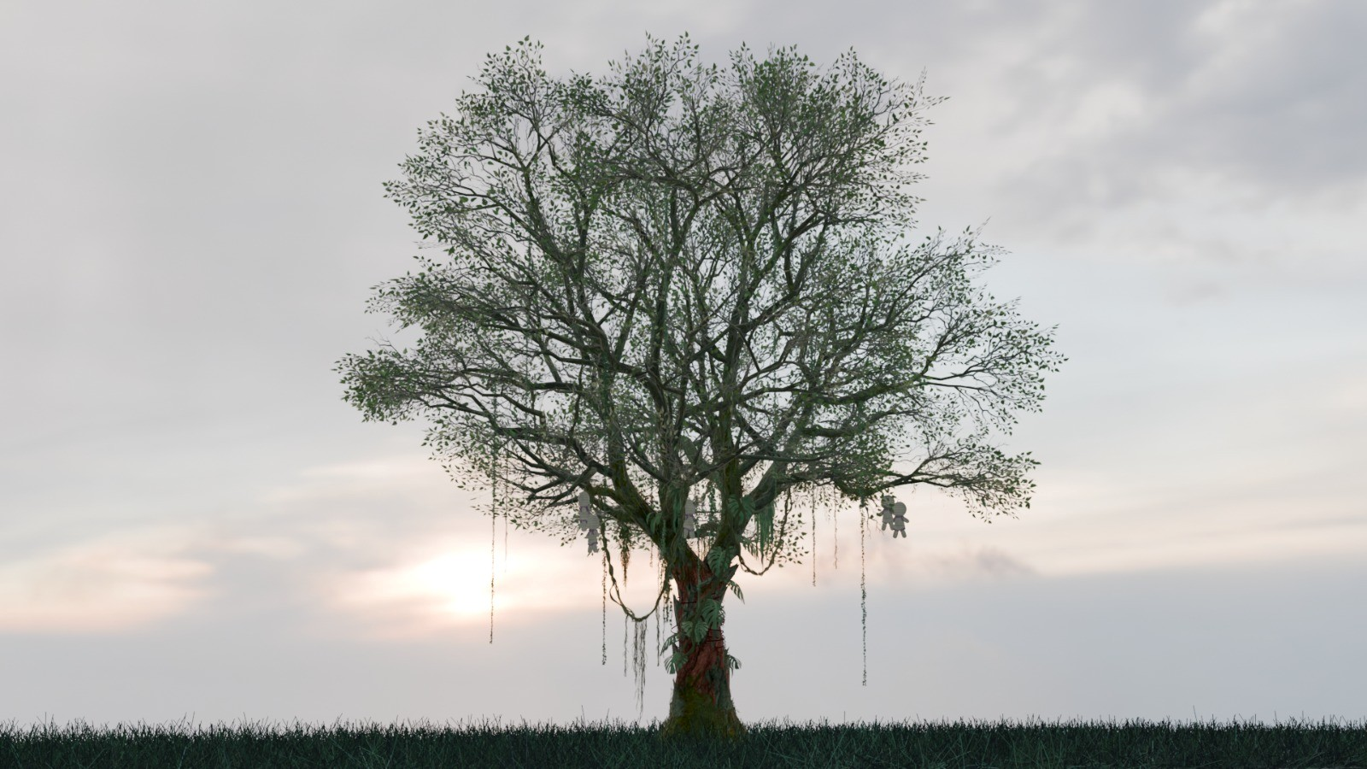

**THE WHISPERING GATE**

**An Interactive Game**

 

**THE WHISPERING GATE**

**FYP**

**GAME DESIGN DOCUMENT**

**Supervisor: Sir Altaf Hussain**

**ZUHA KAOKAB LAIBA KAMRAN MIRHA SAEED**

# Preface

Welcome to the **Game Design Document (GDD) for *THE WHISPERING GATE***—a game that blends **mystery, psychological horror, and interactive storytelling** into a

gripping **graphical novel experience**. This document serves as a **blueprint** for the game’s development, covering everything from the core concept to mechanics,

characters, and gameplay elements.

The idea for *THE WHISPERING GATE* was born from the fascination with **supernatural folklore, psychological tension, and the consequences of choices**. The game follows a protagonist whose sister is afflicted by a **sinister black magic curse**—a mystery that unravels through eerie visions, cryptic clues, and a journey into **a multiversal nightmare**. Every decision made by the player shapes the story, leading to multiple possible endings, each with its own consequences.

The goal of *WHISPERING GATE* is to create an experience that is both **emotionally intense and intellectually engaging**. With **hand-drawn 2D visuals**, a **dark atmospheric aesthetic**, and **intricately designed puzzles**, the game offers a **deeply immersive narrative** where players must confront **both supernatural forces and their own morality**.

This GDD is designed to guide the development team through every aspect of the game, ensuring a cohesive and engaging final product. It provides a structured

breakdown of the **game’s mechanics, storyline, AI systems, and core gameplay features**, making it a valuable reference throughout the development process.

Whether you are a **developer, artist, writer, or designer**, this document will help in understanding the **vision and execution** of *THE WHISPERING GATE*. We invite you to explore its pages and become a part of creating an unforgettable gaming experience.

# Let the dark mystery unfold.

Contents

Preface 3

Let the dark mystery unfold. 3

Executive Summary 7

1.1 Game Title: 7

1.2 Genre: 7

1.3 Game Description 7

1.4 Target Audience 7

1.4 Platform 7

1.5 Language 7

1.6 Unique Selling Point (USP) 8

1.7 Project Objective 8

1.8 Competitive Analysis 8

2.GAME LOGO 9

3.Game Concept 10

3.1Introduction 10

3.2Story Overview 10

3.3Themes 10

4.Art and Video 11

4.1 Art Direction 11

4.2 Concept Art 11

4.3 Cinematics and Animation 13

4.4 Environmental Design 14

5.Sound and Music 15

5.1 Sound Design 15

5.2 Music 15

6.Story 16

6.1 Main Plot 16

6.2 Characters 17

6.3 Alina (Sister) 20

6.4 The Author 21

6.5 Mysterious Woman (Other Realm) 21

6.6 Author’s Wife 24

6.7 Writer’s Daughter (Mahnoor) 26

7.Multiple Endings 27

8.Gameplay Mechanics 27

8.1 Core Gameplay 27

8.2 Key Features 28

9. Art and Visual Style 28

9.1 Art Direction: 28

9.2 Character Designs: 28

**9.3 UI/UX Design:** 28

9.4 Environment Concepts: 30

10. Technical Specifications 31

10.1 **Game Engine:** 31

**10.2 Target FPS:** 31

11. Flowchart 31

11.1 Main Screen 31

# Executive Summary

## 1.1 Game Title:

**“THE WISPERING GATE”**

## 1.2 Genre:

**Horror Thriller (Interactive Narrative Adventure)**

## 1.3 Game Description

The Whispering Gate is an interactive horror thriller in contemporary Pakistan, mixing local myths with psychological horror. Players must move through haunted jungles, discovering a terrible curse threatening to engulf both the protagonist and his sister. Choice-driven mechanics propel the narrative towards multiple endings depending on the player's choices.

## 1.4 Target Audience

**Primary Audience**: Fans of psychological horror, dark thrillers, and mystery games. Players who enjoy narrative-driven experiences and decision-based gameplay.

**Secondary Audience**: Mobile gamers looking for immersive, story-heavy experiences. PC gamers interested in horror and interactive fiction.

## 1.4 Platform

PC(Windows)

## 1.5 Language

English

## 1.6 Unique Selling Point (USP)

In contrast to typical horror games, The Whispering Gate uses obscure Pakistani black magic legends and culture-based horror content, providing the player with an original and authentic supernatural experience poorly represented in mass-market games. This game also includes choice-based environment so that the player will feel engaging.

## 1.7 Project Objective

This game is developed as a Final Year Project to demonstrate skills in game design, narrative writing, level design, and technical implementation using Unity/Unreal Engine. It aims to showcase a complete game development pipeline from concept to playable prototype.

## 1.8 Competitive Analysis

* + - *Life is Strange*: A narrative-driven game with branching choices and emotional depth.
    - *Oxenfree*: A supernatural horror adventure with a focus on atmosphere and story.
    - *Doki Doki Literature Club*: A horror visual novel that subverts expectations and delivers a psychological twist.

# 2.GAME LOGO

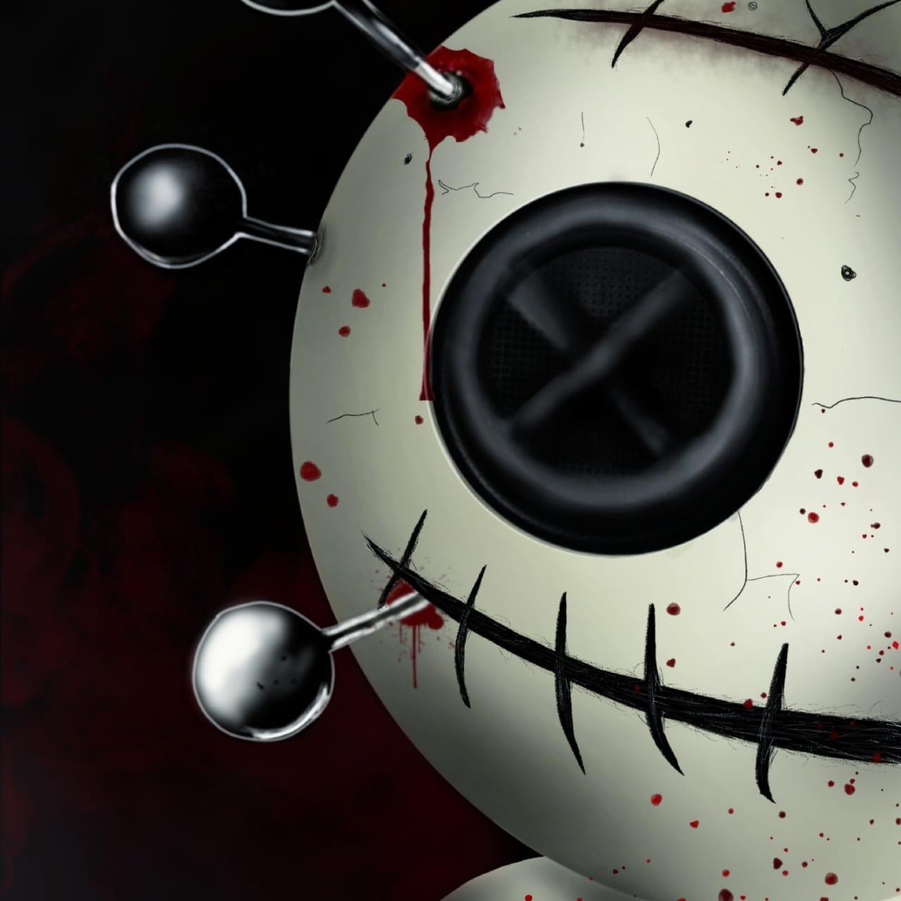

# 3.Game Concept

## 3.1Introduction

*THE WHISPERING GATE* is an immersive, interactive 2D psychological horror graphic novel designed for mobile platforms (Android/iOS) and PC (Steam). Combining narrative-driven gameplay with psychological horror and mystery, the game will place the player in the shoes of a protagonist searching for a way to break a curse afflicting his sister. With elements of black magic, the multiverse, and dark rituals, *THE WHISPERING GATE* offers a compelling story where every choice made will affect the game's outcome, leading to multiple endings. The game's atmosphere is designed to keep players on edge, using eerie soundscapes, disturbing visuals, and an

intricate web of secrets and lies.

## 3.2Story Overview

The protagonist's sister, Alina, is cursed by a powerful and ancient black magic. Desperate to find a cure after all traditional methods have failed, the protagonist discovers a chilling article written by a deceased journalist, who was investigating the curse. The article leads him to the writer's daughter, who reveals a journal with critical information about breaking the curse. The protagonist must travel to a dark jungle, find a cursed ruin, and perform a dangerous ritual in a parallel, twisted version of reality.

## 3.3Themes

The game explores the following themes:

* + - **Desperation**: The protagonist's struggle to save his sister drives his every action.
    - **Fate and Free Will**: Player choices throughout the game will significantly alter the outcome.
    - **Loss and Sacrifice**: The protagonist may face difficult decisions where he must choose between his own safety and his sister's survival.
    - **Psychological Horror**: The line between reality and nightmare blurs as the protagonist descends into madness.

# 4.Art and Video

## 4.1 Art Direction

The art direction for *THE WHISPERING GATE* will focus on creating an eerie, atmospheric experience using hand-drawn 2D visuals. The characters and environments will

have a sketchy, faded appearance, giving them a sense of decay and distortion. The dark, monochromatic color palette will be contrasted with bursts of deep reds, blues, and purples to emphasize supernatural elements.

* + - **Character Design**: Characters will be drawn in a semi-realistic, detailed style, with expressive eyes and subtle animations that communicate fear, sadness, and tension. The protagonist will have a weary look, as though he’s been pushed to the edge by his desperate search for answers.
    - **Environments**: Locations such as the jungle, cursed ruins, and dark world will have a decayed, unsettling aesthetic. The use of shadow and light will play a key role in making the environment feel foreboding, as the player can never truly escape the feeling of being watched.
    - **Supernatural Effects**: Distorted reality will be represented by visual glitches, odd color tints, and shifting environments, which will be seen most prominently in the “negative” version of the jungle and ruined structure.

## 4.2 Concept Art

**Tree with Hanging Voodoo Dolls**

* + - **Description**: The protagonist wakes up under a dark, twisted tree in the cursed dimension. From its branches hang several voodoo dolls, their eyes made of dark, shimmering beads, and their bodies stitched together with what seems like dark magic. The tree is surrounded by dense fog, and the atmosphere is charged with an ominous sense of foreboding.
    - **Purpose**: This tree marks the protagonist's entry into the world of curses, symbolizing the beginning of his journey into the supernatural. The voodoo dolls serve as both visual markers and plot devices, hinting at the twisted magic that controls the cursed world.
    - **Visual Style**: Dark, grainy, hand-drawn texture, with heavy use of shadows and light to emphasize the eerie, foreboding atmosphere.

**Modelled Asset**

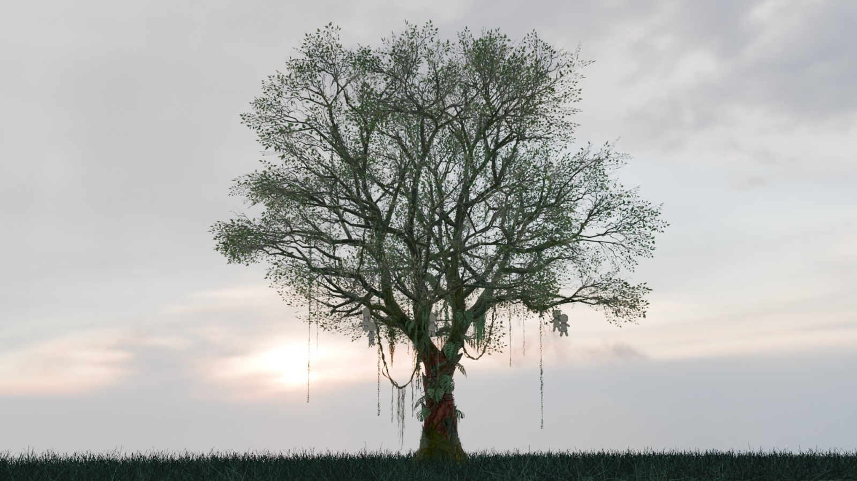

**Portal in the Forest**

* + - **Description**: Deep in the jungle lies a mysterious, glowing portal, an entrance to the alternate, cursed version of the world. The portal is surrounded by twisted trees, some of which are barely visible through the thick mist. The ground near the portal is disturbed, and strange, unearthly symbols are carved into the surrounding trees. The portal flickers with an unsettling light that seems to warp reality itself.
    - **Purpose**: This portal represents the gateway between the real world and the dark, alternate reality. It is the point of no return for the protagonist as he steps into a dangerous realm that will test his resolve and ultimately

determine his sister’s fate.

* + - **Visual Style**: Eerie lighting, with the portal appearing almost as though it’s alive, pulsing and shifting. The environment around it is dark and decayed, with elements that seem to shift and distort.

**Sketched**

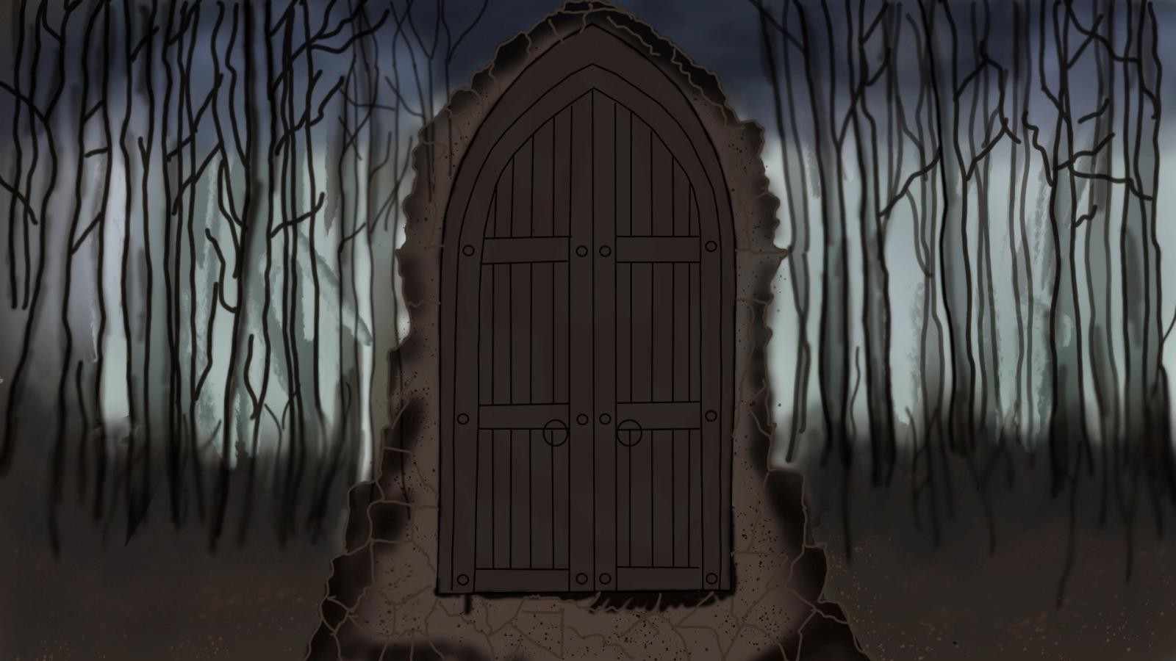

**Modelled Asset**

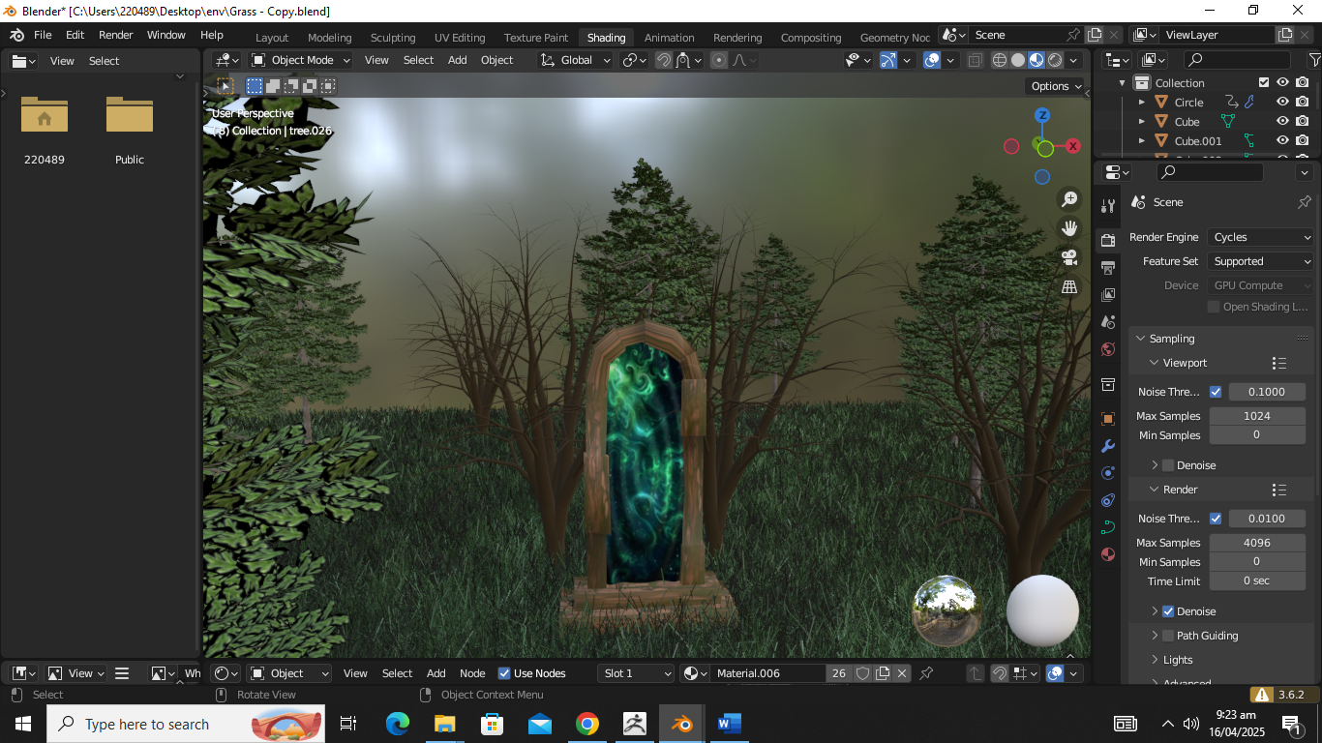

## 4.3 Cinematics and Animation

* + - The game will feature animated cutscenes that provide context to major events, such as visions, nightmares, and key decisions.
    - Animations will be used sparingly but effectively to enhance the horror elements, like supernatural creatures appearing out of nowhere or the protagonist performing the ritual.
    - In addition to cinematic sequences, certain in-game moments will include small animations that convey emotional depth, such as trembling hands, quick glances, and subtle facial expressions.

## 4.4 Environmental Design

The environment will feel alive and oppressive, with subtle environmental storytelling:

* + - **The Apartment**: The protagonist’s apartment will be small and cramped, reflecting his deteriorating mental state. The clutter of bills and personal items shows his growing desperation.

**The Writer’s House**: A dusty, dimly lit space filled with books, papers, and personal belongings. Here, the player will uncover secrets about the curse and its origin.

* + - **The Jungle**: A dense, overgrown jungle with creeping fog and twisted trees. It represents the unknown and the beginning of the protagonist’s journey into the supernatural.
    - **The Ruined Structure**: The structure will be an eerie, decayed ruin, filled with strange carvings and artifacts. It feels otherworldly, and the player can feel the magic and danger in the air.
    - **The Cursed World**: A dark, twisted version of the jungle, where everything is distorted and unnatural. Trees are barren, and the sky is perpetually dark and foggy, filled with strange sounds and haunting echoes.

# 5.Sound and Music

## 5.1 Sound Design

The sound design will play a major role in building atmosphere and tension:

* + - **Ambient Sounds**: Background noises like wind, creaking wood, distant animal calls, and eerie whispers will make players feel like they are never truly alone.
    - **Supernatural Sounds**: Strange sounds will be present when the protagonist is in the cursed world—distorted whispers, sudden loud noises, and unidentifiable screeches. The sounds will grow more intense as the protagonist's mental state deteriorates.
    - **Character Sounds**: The protagonist’s breathing, footsteps, and whispers will intensify during moments of fear or tension, adding to the emotional weight of key scenes.

## 5.2 Music

The soundtrack will focus on creating a sense of dread and emotional conflict:

* + - **Main Theme**: A haunting, somber melody that plays during introspective moments.
    - **Tension Music**: Slow-building music that increases in intensity during moments of danger or suspense, signaling the presence of supernatural forces.
    - **Cursed World Music**: A distorted version of the main theme will be used when the protagonist enters the otherworldly jungle, with dissonant notes to increase unease.
    - **Ritual Music**: Dark, ritualistic chants and percussion that build to a climactic point when the protagonist attempts to break the curse.

# 6.Story

## 6.1 Main Plot

The game follows a protagonist who embarks on a quest to save his sister, Alina, who has been cursed by an ancient black magic. Despite the efforts of doctors, spiritual experts, and religious figures, nothing works. The protagonist stumbles upon an article written by a journalist who had researched this very curse. The

article leads him to a journal belonging to the journalist’s daughter. With this journal, the protagonist discovers the location of a ruined structure hidden deep in a jungle. Within this ruin is a portal to a dark, parallel world where the curse can be broken—if the protagonist can perform the right ritual.

The game will be split into four main chapters:

1. **The Search**: The protagonist’s search for answers begins at his apartment. This chapter includes the introduction to the curse and the protagonist’s first encounter with the writer’s daughter.
2. **The Journey**: The protagonist travels to the jungle and explores the ruins.
3. **The Ritual**: Upon entering the otherworldly version of the jungle, the protagonist must perform the ritual to attempt to save his sister.
4. **The Consequences**: Depending on the player’s choices, the ritual may succeed or fail, and the story will take a drastically different direction.

## 6.2 Characters

1. **Protagonist**
   * **Role**: Main character, determined to save his sister.
   * **Backstory**: The protagonist is a regular person who is thrust into a supernatural situation when his sister, Alina, becomes cursed by black magic. Throughout the story, he shows resilience and desperation as he seeks answers, faces terrifying experiences, and makes life-altering decisions. His personality is shaped by the player's choices—he can be compassionate, ruthless, scared, or determined, leading to different outcomes.
   * **Personality Traits**: Determined, curious, morally complex, and occasionally conflicted.
   * **Goal**: To break his sister's curse and uncover the truth behind the mysterious forces at play.

**Sketched**

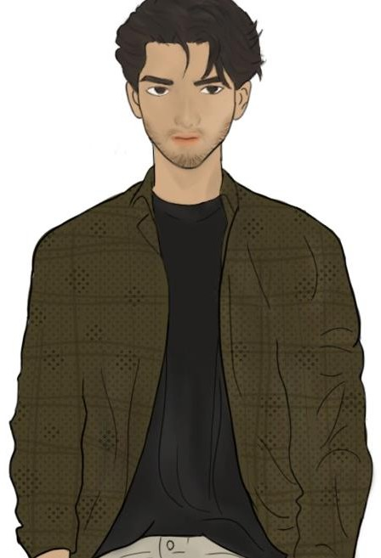

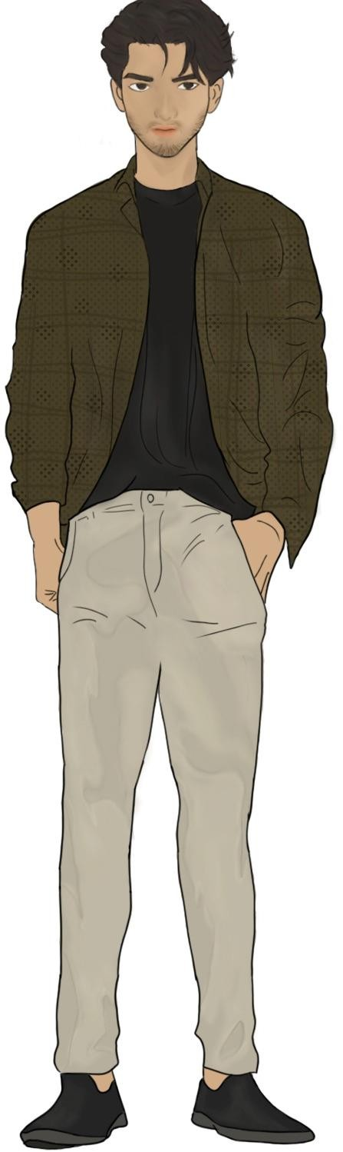

**Modelled Asset**

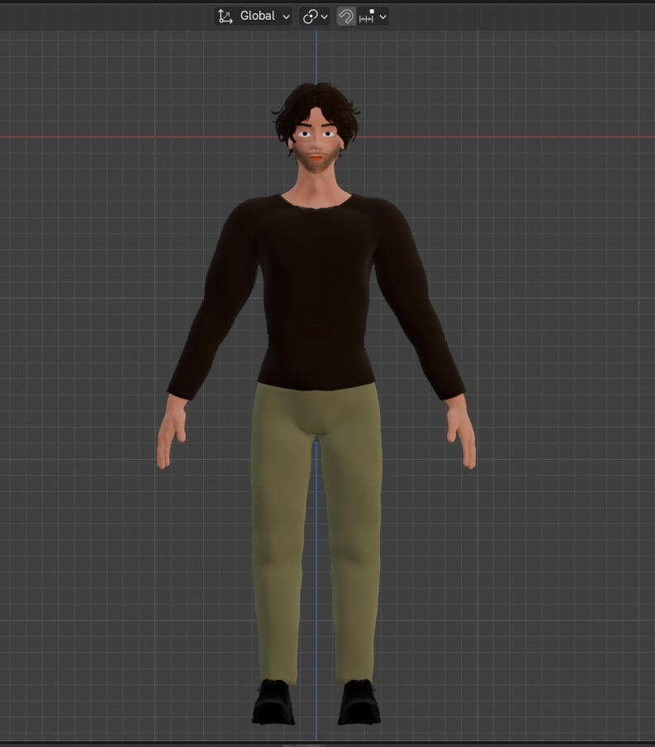

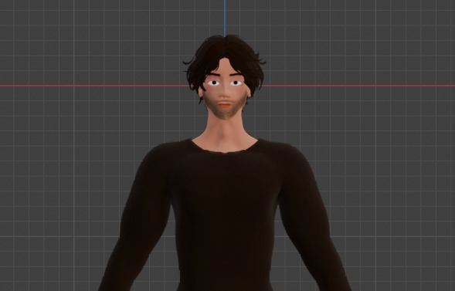

## 6.3 Alina (Sister)

* + **Role**: The cursed sibling, whose fate depends on the protagonist's choices.
  + **Backstory**: Alina is the sister of the protagonist, and she becomes cursed by an ancient black magic. As the curse slowly consumes her, she becomes

increasingly weak, but her bond with the protagonist remains strong. She is a passive character who suffers throughout the story, with her fate tied to the protagonist's actions.

* + **Personality Traits**: Vulnerable, trusting, and deeply connected to the protagonist.
  + **Goal**: To survive the curse, though her chances depend on the protagonist's success in breaking the curse.

## 6.4 The Author

* + **Role**: A pivotal character whose research and writings on the curse lead the protagonist on his journey.
  + **Backstory**: The Author was a respected journalist and writer who delved into the occult and supernatural, believing he could uncover the truth behind ancient curses. His investigation into the curse that afflicts the protagonist's sister led him to write an article about it, a piece that seemed to be the only public account of the curse’s existence. However, shortly after publishing the article, the Author mysteriously died under suspicious circumstances. Unbeknownst to the protagonist, his death is connected to the curse he wrote about, and his investigation may have ultimately drawn the attention of malevolent forces. It is only through his daughter that the protagonist learns more about the curse and the journal hidden in the writer's study.
  + **Personality Traits**: Intelligent, inquisitive, and determined, but also haunted by the curse’s dark forces. The Author’s curiosity pushed him to the edge of danger, ultimately costing him his life. He is now a tragic figure, a cautionary tale for those who dare to uncover the truth.
  + **Goal**: To uncover the truth behind the curse and its origins, even at the cost of his own life. He hoped his research would provide the key to stopping it, but his work serves as a warning to others, showing that some knowledge is too dangerous to seek.

## 6.5 Mysterious Woman (Other Realm)

* + **Role**: A supernatural figure who appears in the alternate dimension.
  + **Backstory**: The Mysterious Woman exists within the cursed, negative version of the world. She is a key figure in the protagonist’s quest to break the curse. At first, she seems ominous, but later, her true intentions become clear—she offers to help the protagonist perform the ritual needed to break the curse, though at a great personal cost.
  + **Personality Traits**: Enigmatic, wise, and emotionally detached.
  + **Goal**: To guide the protagonist in performing the ritual but with her own agenda, which may not be entirely benevolent.

**Sketched**

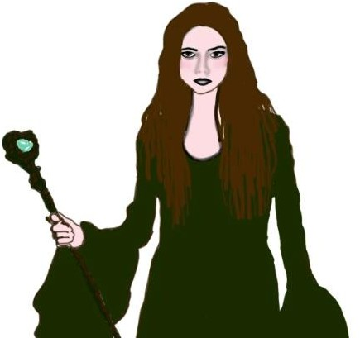

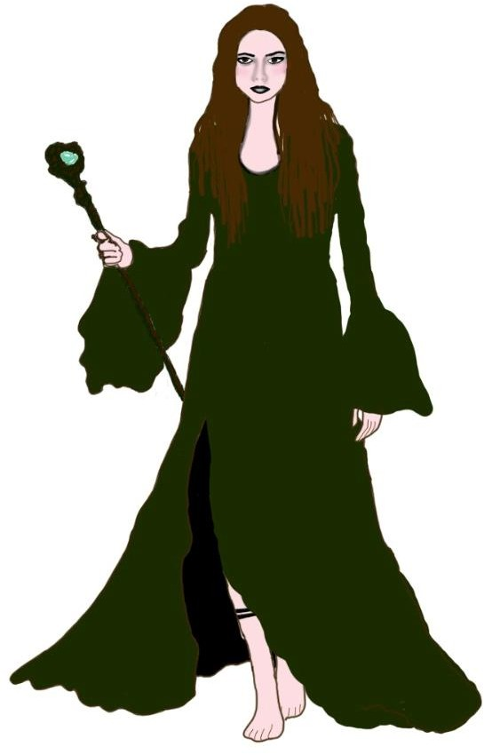

**Modelled Asset**

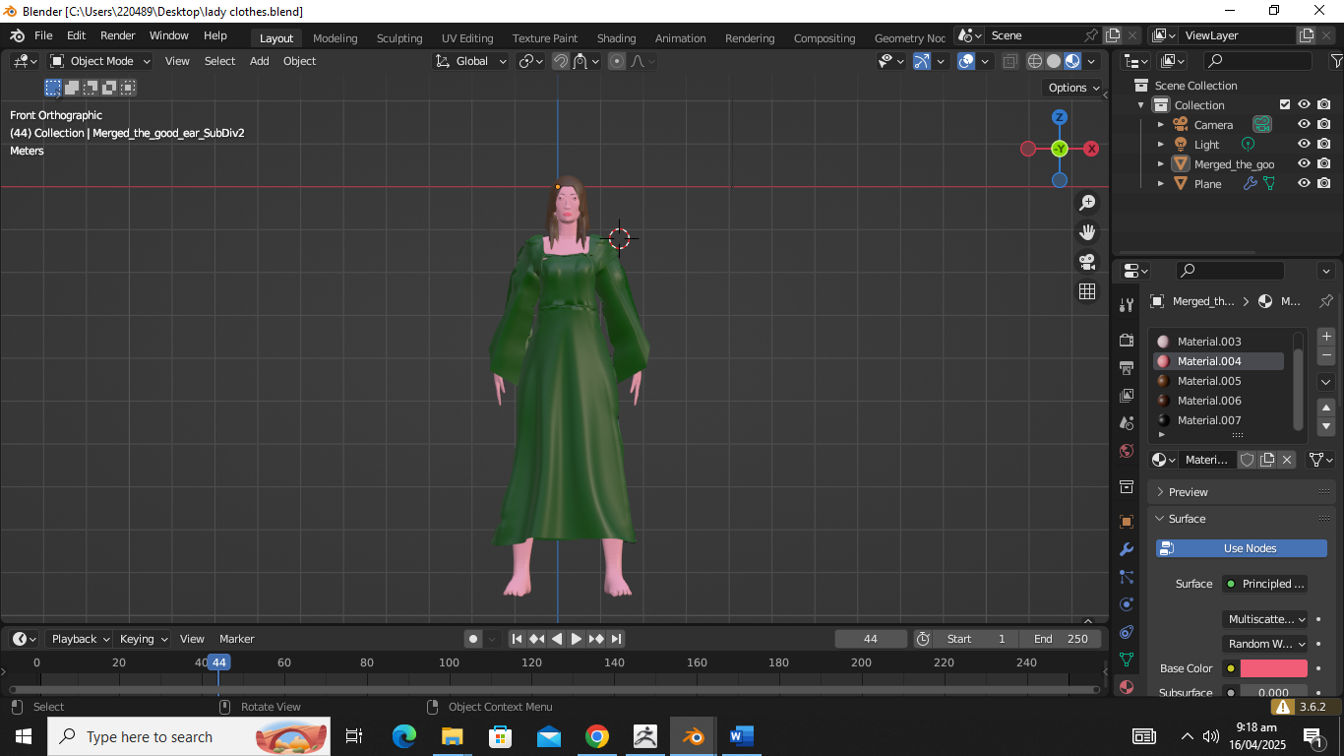

## 6.6 Author’s Wife

* + **Role**: A key character who is revealed to have died from the curse, but the twist is that she is alive in the other world.
  + **Backstory**: The Author's Wife was once a loving and supportive partner to the writer, who was deeply invested in understanding the curse. However, she tragically became a victim of the curse herself. Her death seemed to be

the tragic conclusion of the curse’s reach. But in a shocking twist, it is revealed that she is alive in the other, cursed version of the world, where she has become an ethereal and almost ghostly presence. The protagonist learns that the writer’s desperate attempts to save her might have caused the curse to shift onto his own daughter or the protagonist’s sister.

* + **Personality Traits**: Haunting, melancholic, and conflicted. Her spirit is torn between the love she once had and the torment of the curse. She is at times a source of guidance, but her true nature and intentions are shrouded in mystery.
  + **Goal**: To either be freed from her own curse or to influence the protagonist’s actions for her own benefit, as she struggles with her existence in the other world and the darkness surrounding her.

**Sketched**

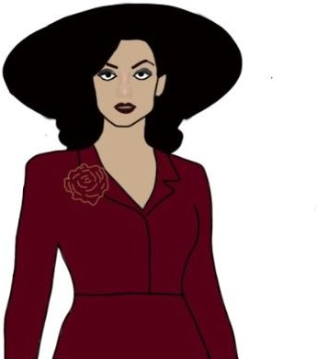

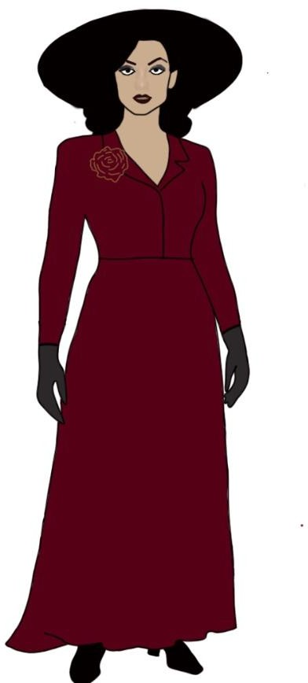

## 6.7 Writer’s Daughter (Mahnoor)

* + **Role**: A secondary character who helps guide the protagonist through the mysteries.
  + **Backstory**: Mahnoor is the daughter of the writer who researched the ancient curse. Her father’s mysterious death left her with the burden of his unfinished work. She helps the protagonist in finding crucial documents and leads him to her father’s study, where he uncovers essential information about the curse.
  + **Personality Traits**: Mysterious, resourceful, and calm under pressure.
  + **Goal**: To aid the protagonist in finding the truth, even if it means confronting the dangerous legacy her father left behind.

# 7.Multiple Endings

The game has five possible endings, each of which depends on the player’s decisions:

1. **Good Ending**: The curse is broken, and Alina is saved. The protagonist returns home safely, and they both begin a new life.
2. **Neutral Ending**: The curse is broken, but the protagonist feels something is still wrong, hinting at future consequences.
3. **Bad Ending**: The ritual fails, and Alina dies. The protagonist returns home, forever haunted by his failure.
4. **Worst Ending**: The protagonist becomes trapped in the otherworld and is lost forever, unable to return to his reality.
5. **Twist Ending**: It’s revealed that the protagonist was indirectly responsible for the curse all along. His desperation to save his sister led him to make choices that triggered the curse in the first place.

# 8.Gameplay Mechanics

## 8.1 Core Gameplay

* + - **Point-and-Click Exploration**: The game is played through a combination of interactive dialogue and exploration. Players will explore the

environment, interacting with objects and characters to uncover the story.

* + - **Decision-Making**: Dialogue choices and actions influence the narrative, leading to different paths and outcomes.
    - **Puzzle-Solving**: Players will need to solve various puzzles, such as

deciphering the journal, uncovering hidden locations, and figuring out how to perform the ritual.

* + - **Ritual Mechanic**: The protagonist must collect specific items and perform rituals at certain points in the game to break the curse. The ritual’s success depends on the player’s choices and the sequence of actions taken.

## 8.2 Key Features

* + - **Multiple Dialogue Choices**: Each choice has consequences, altering the story's path and character interactions.
    - **Inventory System**: The protagonist will collect and use various items such as keys, charms, and journals, which will be essential for solving puzzles and performing the ritual.
    - **Sanity Mechanic**: The protagonist’s mental state will be affected by the horrors he encounters. As his sanity deteriorates, the environment becomes more distorted, and supernatural forces grow stronger.

# 9. Art and Visual Style

## 9.1 Art Direction:

Dark color palette, misty atmosphere, eerie lighting.

## 9.2 Character Designs:

Modern Pakistani casual outfit.

## **9.3 UI/UX Design:**

**Main Menu Screen**

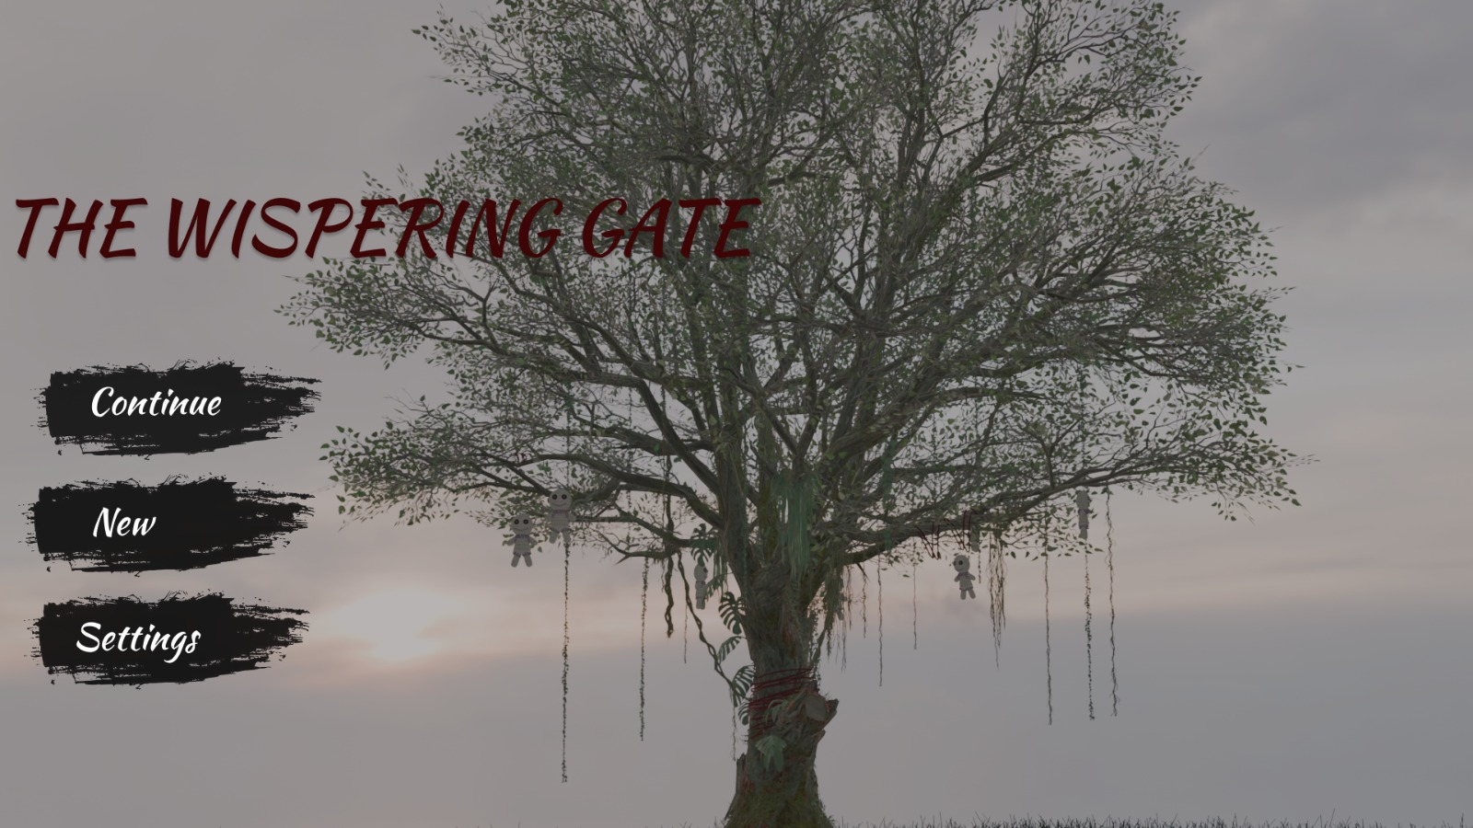

**Loading Screen**

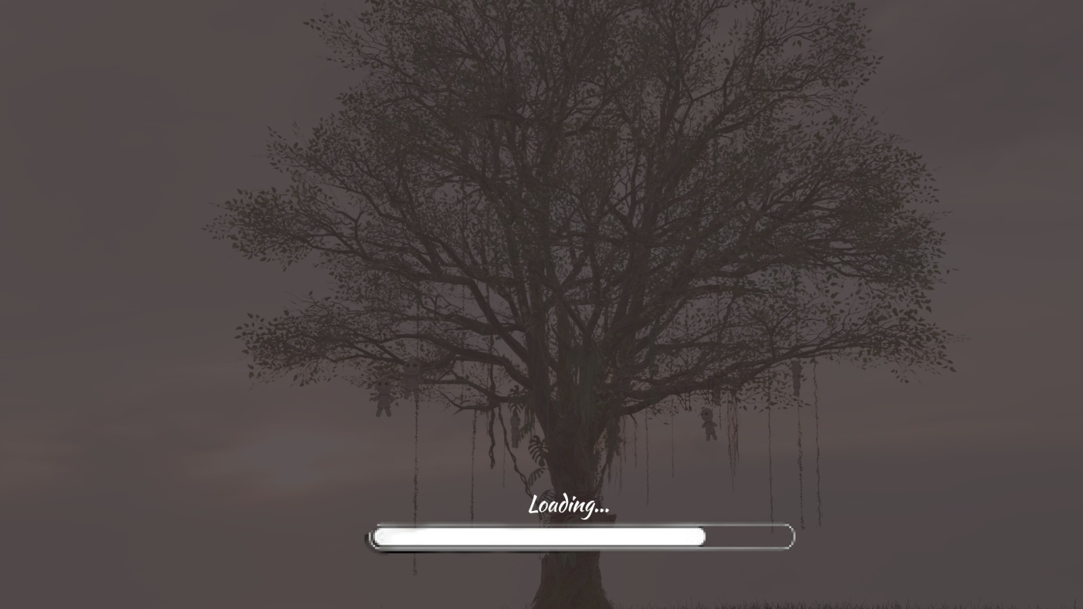

**Choice Making Screen**

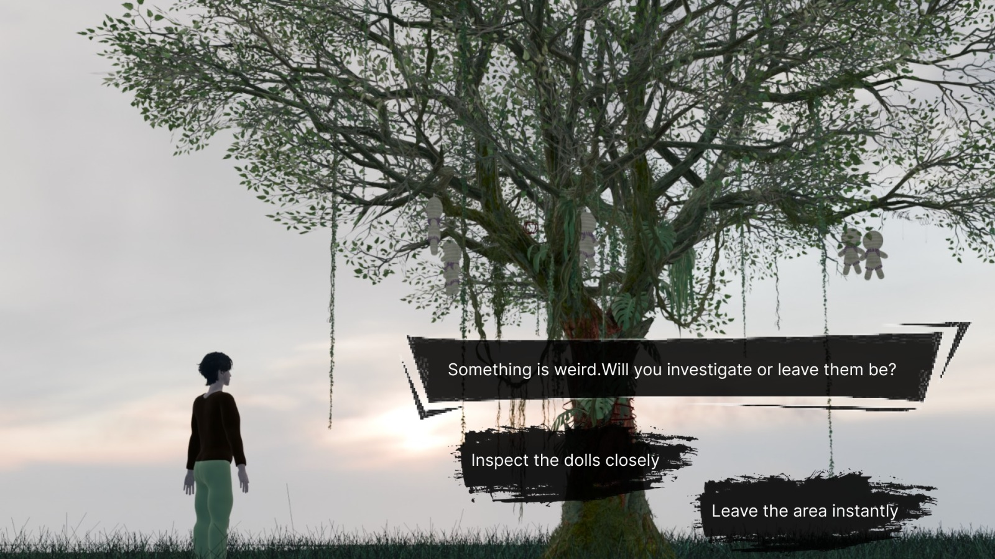

## 9.4 Environment Concepts:

# env

# env 2

# 10. Technical Specifications

## 10.1 **Game Engine:**

Unity, Unreal Engine.

## **10.2 Target FPS:**

60 FPS if possible.

# 11. Flowchart

## 11.1 Main Screen

# 

Loading

Main

Screen

New Game

New Game

Graphics

Back

Audio

Settings Menu

Last saved Screen

Settings

Continue